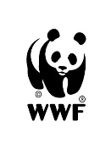

This project is funded
by the European Union

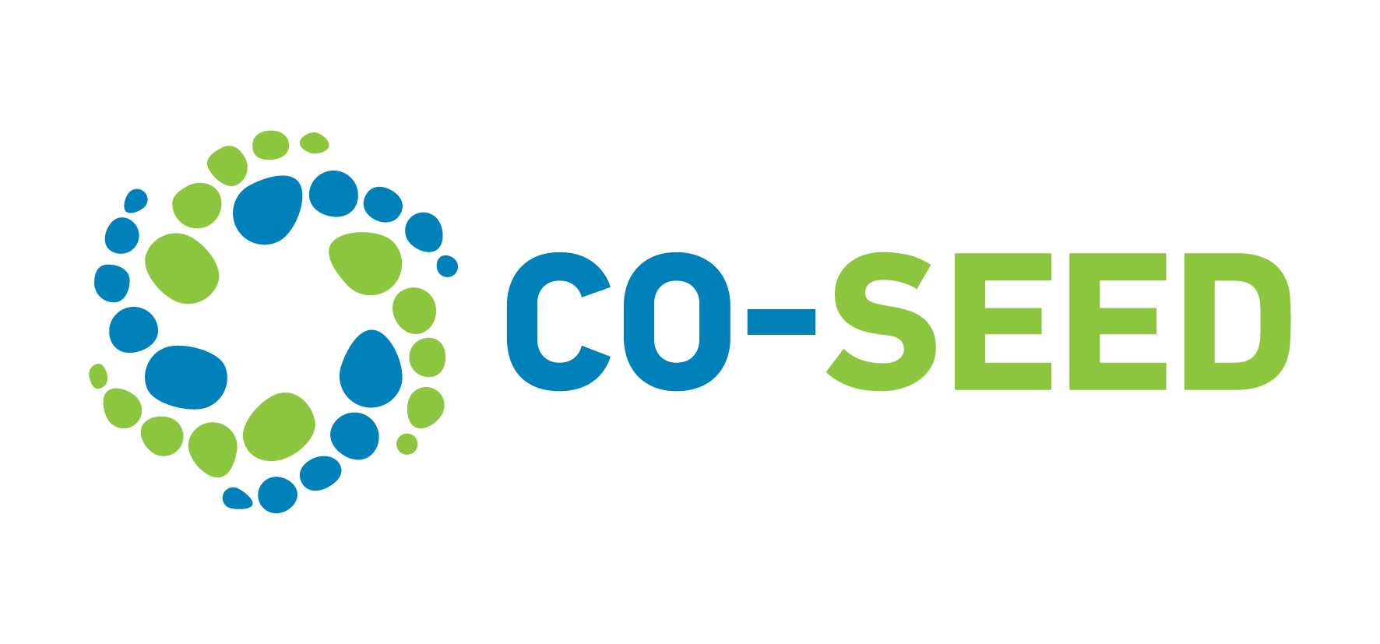

Civil Society

Capacity Building and Advocacy

Grant Program

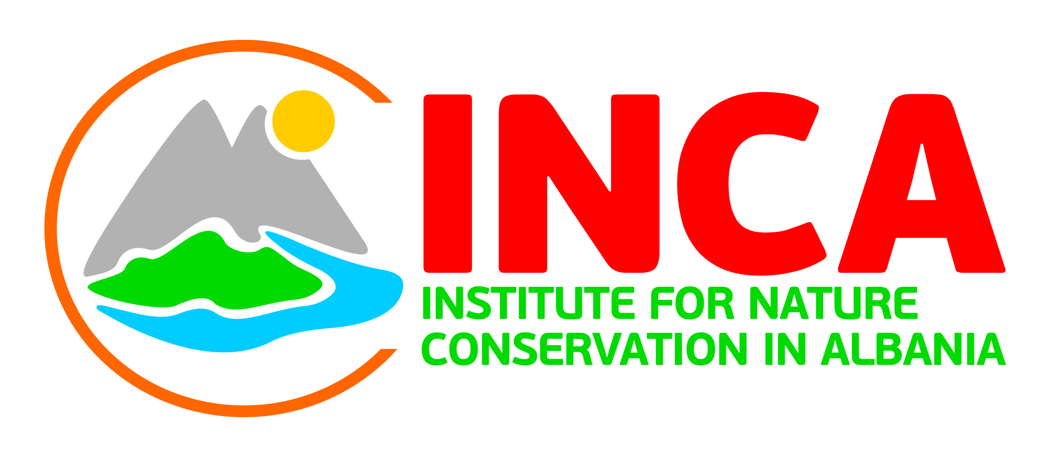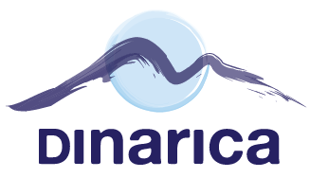

A. Civil Society Acts for Environmentally Sound Socio-Economic Development (CO-SEED)

Declining natural resources, loss of biodiversity and climate change seriously threaten the environmental conditions necessary for human existence and the foundations of our economic prosperity. All these problems stem from the overuse of natural resources, which can be remedied if we follow sustainable development principles when planning the use of natural assets.

Within this context, the Action titled Civil Society Acts for Environmentally Sound Socio-Economic Development aims to contribute to the sustainable management of natural resources through improved regulatory framework and more participatory and transparent decision-making processes, which involve a vibrant group of civil society organizations and increased attention of the media on the topic, with benefits for society at large.

The Action has officially started in February 2016 and has a duration of 36 months It involves five beneficiary countries; namely Albania, Bosnia and Herzegovina, Montenegro, Serbia and Turkey. The project partners are:

- WWF-Turkey (Doğal Hayatı Koruma Vakfı), Turkey as the project coordinator;
- Green Home ( Zeleni Dom – Green Home Udruzenje), Montenegro;
- BPSSS (Bird Protection and Study Society of Serbia), Serbia;
- Dinarica ( Udruga Dinarica), Bosnia and Herzegovina;
- INCA (Instituti per Ruajtjen e Natyrë në Shqipëri), Albania;
- WWF Adria (Udruga za zastitu prirode i ocuvanje bioloske raznolikosti), Croatia.

Within the Action, capacity building of civil society organizations (CSOs) from each of the five countries is aimed via awarding them financial support. Consequently, beneficiary CSOs will increase their knowledge and technical background to provide sound comments in the EIA/SEA public consultations and strengthen their capacity to lobby and stand constructively for their views. The beneficiary CSOs will form a regional network together with the project partners while attending the main project activities.

1. Purpose of the Program

It is the best practice internationally and a long-term EU legal practice to assess sustainability at the planning stage of any proposed undertaking possibly affecting natural resources, and this is achieved through Environmental Impact Assessments (EIAs) for projects and Strategic Environmental Assessments (SEAs) for plans and programs. In order to ensure comprehensive, objective, transparent and inclusive assessments, their decision-making processes provide for public consultations during which all interested and affected parties may state their opinion of the project, plan or program. Although EIA and SEA appear only environment-oriented, they address a wide range of issues, such as rural and social development, sustainable resource use, participatory governance, environmental justice, etc. Therefore, civil society participation in these decision-making processes is critical for strengthening participatory democracies, increasing ownership over decisions that affect a society’s future and assisting the achievement of sustainable development.

The global objective of the program is to stimulate an enabling legal and financial environment for civil society and pluralistic media, as well as to empower civil society and media organizations to be effective and accountable independent actors, and to improve their capacity to dialogue with governments influencing policy and decision making processes and holding them accountable for their performance towards citizens and society at large.

The specific objective is that by end of the program civil society organizations in the five countries are engaged as equal stakeholders with public authorities and professional companies in their national processes of legislative revisions and decision making on EIAs and SEAs through inter alia increased media attention.

2. Expected Outcomes of the Action

The pillars on which the attainment of the objective lies are captured in the four specific results, which address smooth running of the Action:
- Building the capacity of the CSOs on lobbying and advocacy
- Improving regulatory framework for EIAs and SEAs
- Influencing EIA/SEA public consultations
- Raising the attention of media while increasing their capacity to flag out issues around public consultation processes reflecting the importance of CSOs participation

Civil Society Capacity Building and Advocacy Grant Program

B. 1. Goals and Priorities of the Program

The program aims to build capacity at civil society organizations from each of the five countries that are interested in related topics and which become the beneficiaries of financial support awarded through the Grant Program.
Activities under this Program are aimed at
- increasing beneficiary CSOs’ knowledge and technical background to provide sound comments in the EIA/SEA public consultation,
- strengthening their capacity to lobby and stand constructively for their views. (CSOs receiving financial support will attend capacity building events.)

Civil Society Capacity Building and Advocacy Grant Program has been designed with the purpose of strengthening capacities of selected organizations to actively engage in policy and advocacy. This will be accomplished by providing capacity building trainings on policy and advocacy, and opportunities for practical implementation of gained knowledge to EIA and SEA decision-making processes.

Workshops and trainings will be done regionally to disseminate knowledge while facilitating exchange of information and best practices among project partners and beneficiary CSOs. Beneficiary CSOs will transfer the knowledge and expertise gained to peer/local CSOs.

B.2. Project Indicators

Civil Society Capacity Building and Advocacy Grant Program aims to reach the following project indicators. Prospective applicants should address how their project objectives overlap with these indicators.

- CSOs involvement and active engagement in EIA and SEA public consultations increased
- Local/national media is engaged to follow CSO negotiations with public authorities
- Media coverage on CSO involvement in decision making processes on sustainable use of natural resources increased
- CSOs capacity and autonomy for engaging and lobbying increased
- CSOs, public authorities and professional companies’ capacity increased for evaluating completeness of EIA and/or SEA
- Roadmap created for regulatory framework improvement within a participatory process
- Policy recommendations for EIA and SEA are submitted to public authorities

B.3. General Outline

Civil Society Capacity Building and Advocacy Grant will be awarded in the five countries that participate in the Civil Society Acts for Environmentally Sound Socio-Economic Development Action. Eligible organizations may apply alone or form national and/or international partnerships. Each prospective organization will submit applications in the country where their organization is officially registered. Grantees will be responsible to the National Project Officer in the country they are registered.

In addition to designing own activities, beneficiary CSOs will use these funds to cover expenses to attend two technical training and two networking events organized in the participating countries within the framework of the Action. Grantees are also strongly encouraged to follow and attend public consultations of EIAs and SEAs (where applicable).

Grants will be awarded to at least a total of 15 organizations, thus each applicant will be evaluated nationally and internationally with their counterparts in Albania, Bosnia and Herzegovina, Montenegro, Serbia and Turkey.

Prospective organizations are encouraged to increase the impact of their actions by way of forming national and/or international partnerships before applying. When equal conditions arise, applications with partnerships will be given priority.

B.4. Eligibility

Organizations registered in the following five countries will be eligible for financial support: Albania, Bosnia and Herzegovina, Montenegro, Serbia and Turkey.

Eligible organizations may be any of the following civil society organizations:
- rights-based organizations,
- community-based organizations,
- non-governmental organizations,
- civil initiatives active in environment and nature, or participatory governance/democratization

Applicants should
- be active for at least 2 years, verified by excerpt from national registry,
- have main field of work as protection of environment and nature, or participatory governance/democratization (lobbying, building citizen awareness and competence, encouraging public participation, transparency, access to information, political representation) of society with a track record in environmental protection, verified by list and summary of previous projects/activities;
- Project Manager of the Grantee Organization to sufficiently communicate in English in order to actively participate in the capacity building events listed below, engage with international counterparts and exchange information.

Capacity Building Events Timeline
Project Manager of the Grantee Organization will be obliged to attend the following events. Applicants should budget travel and accommodation costs for these events in their application.

- 3 days networking meeting and capacity building workshop on advocacy and lobbying, Istanbul, November 2016
- 2 days training on participation to EIA and SEA processes, Albania, December 2016
- 2 days training on assessing adequacy of prepared EIA and SEAs, Serbia, Date TBD in 2017
- 2 days networking meeting, Montenegro, Date TBD in 2018

* Grantees are also strongly encouraged to participate in the public consultation meetings of EIA and SEA where applicable.

B.4.1. Partnerships

Organizations may form national, regional and/or international partnerships to increase the impact of their project and their chances of being awarded a grant. If applying with a partner, a single application form, work plan and budget should be submitted, but each of the partners should provide the legal documents as they pertain to their organization, separately. Budget should reflect financial responsibilities of each of the partners individually. Partnerships should have sound reasoning with each partner bringing individual expertise into the project and assuming necessary responsibility, creating an effective and cohesive project idea and plan for implementation.

If formed internationally, the leading applicant in the partnership will need to submit the application in the country of their legal registry.

B.5. Eligibility of Expenses

B.5.1. Actions Eligible for Funding

In the application process, the applicant organizations will be required to propose activities that complement and follow-through on other activities planned under this Action, and which may fit any of the following types of activities:
- training actions, study visits and field trips;
- facilitation of contacts, consultations and discussions between different stakeholders;
- communication and information activities aimed at supporting consultation with stakeholders;
- organization of roundtables, workshops and seminars;
- drafting policy or legislation recommendations;
- promotion of the implementation of adopted laws and regulations;
- advocacy for the revision of existing legislation and adoption of new legislation in accordance with EU standards and requirements;
- establishment of dialogue with political parties, groups of parliamentarians or legislative bodies;
- establishment of dialogue with stakeholders relevant for the EIA/SEA decision-making process;
- establishment of dialogue with peer CSOs or CSOs active in other fields which may have specific knowledge/expertise with added value for the EIA/SEA decision-making process;
- collaboration with independent experts;
- public awareness raising campaigns.

Please note that all spending under the Program is VAT exempt therefore should budget the costs without VAT.

B.5.2. Actions Non-eligible for Funding

Following actions will not be funded through the Grant Program:
- debts and provisions for losses or debts;
- interest owed;
- items already financed in another framework;
- purchases of land or buildings;
- currency exchange losses;
- taxes;
- credits to third parties.

B.6. Type and Amount of the Grant

Civil Society Capacity Building and Advocacy Grant will award 252,000 Euros in total in five countries. At least 15 organizations will be awarded in Albania, Bosnia and Herzegovina, Montenegro, Serbia and Turkey thus the applications will be evaluated nationally and internationally. At least one applicant from each country will be awarded the Grant.

Only financial award will be granted by the Action; applicants will be responsible from budgeting and arranging travel and accommodation for the mandatory capacity building events listed under B.4. Eligibility.

Grant award will be transferred in the local currency and will cover the entire budget submitted to the extent of funds available. Applicants should provide budget prepared in currency of Euro.

B.7. Geographical Reach

Project could be implemented nationally, regionally or internationally within Albania, Bosnia and Herzegovina, Montenegro, Serbia and Turkey.

B.8. Timeline of the Grant

Projects to be awarded a grant should be implemented between November 1, 2016 and October 31, 2018.

B.9. Visibility

Grantees will be obliged to abide by the visibility rules defined by theNational Project Officer in their country.

Applications

How to Apply

Applications and all supporting documents mentioned on this guideline must be sent to emi_adhami@hotmail.com by August 25th, 2016. Only the submissions listed in this guideline and forms listed on the checklist will be evaluated. Do not send additional documents unless specifically stated on the application form. Prospective applicants may send questions about the Grant Program or about the documents to be submitted to the same email address mentioned above until August 11th.

*If applying with a partner, a single application form, work plan and budget should be submitted but each of the partners should provide the legal documents as they pertain to their organization, separately. Budget should reflect financial responsibilities of each of the partners.

*Concept notes will not be requested. Once submitted, applicants will not be allowed to make any changes to their applications however, if needed, National Project Officer may contact the applicant for further clarification.

* Applications should reflect how the project objectives overlap with the Grant Program Indicators listed under B.2. Project Indicators of this guideline.

* Applicants may submit more than 1 project application; only one project per organization will be awarded a grant either with or without a partnership.

C.2. Selection Process and Scoring

Applications will be evaluated based on their relevance to the objectives of the Action and how effectively they address the Project Indicators. Applications will be assessed among the international applications from five participating countries following the assessment and scoring of a national, independent advisory board.

Completion of evaluations and the announcement is expected to take place in September 23rd 2016.

C.2.1. Scoring

The evaluation criteria are divided into sections and subsections. Each subsection will be given a score between 1 and 5 in accordance with the following guidelines: 1=very poor; 2=poor; 3=adequate; 4=good; 5=very good.

Only projects scoring minimum 70 points will be proposed for grants award, depending on the funds available.

Some of the scores on this evaluation grid are given twice points to weigh in favorable aspects of the projects.

C.2.2. Evaluation Grid

Section | Maximum Score
1. Financial and operational capacity | 15
1.1 Does the applicant (and partners) have sufficient experience? (notably on the issues to be addressed) | 5
1.2 Does the applicant (and partners) have sufficient technical expertise? (notably knowledge of the issues to be addressed) | 5
1.4 Does the applicant have stable and sufficient sources of human and financial resources? | 5
2. Relevance | 25
2.1 How relevant is the proposal to the objectives and one or more of the project indicators of the call for proposal? | 5 x 2
2.2 How relevant is the proposal to the particular needs and constraints of the target country/countries or region(s)?(including avoidance of duplication and synergy with other initiatives) | 5 x 2
2.3 How clearly defined and strategically chosen are those involved (final beneficiaries, target groups)? Have their needs been clearly defined and does the proposal address them appropriately? | 5
3. Methodology | 30
3.1 Are the activities proposed appropriate, practical and consistent with the objectives and expected results? | 5
3.2 How coherent is the overall design of the action? (in particular, does it reflect the analysis of the problems involved, take into account external factors and anticipate an evaluation?) | 5 x 2
3.3 Does the applicant form a partnership with another local, national or international organization within the scope of the call for proposal? | 5
3.4 Are the partners’ level of involvement and participation in the action satisfactory? | 5
3.5 Does the proposal contain objectively verifiable indicators for the outcome of the action? | 5
4. Sustainability | 15
4.1 Is the action likely to have a tangible impact on its target groups? | 5
4.2 Is the proposal likely to have multiplier effects? (including scope for replication and extension of the outcome of the action and dissemination of information) | 5
4.3 Are the expected results of the proposed action sustainable:  - financially(how will the activities be financed after the funding ends?)  - institutionally(will structures allowing the activities to continue be in place action?)  - at policy level (where applicable)(what will be the structural impact of the action – e.g. will it lead to improved legislation, codes of conduct, methods etc?) | 5
5. Budget and cost-effectiveness | 15
5.1 Is the ratio between the estimated costs and the expected results satisfactory? | 5x2
5.2 Is the proposed expenditure necessary for the implementation of the action? | 5
Maximum total score | 100

C.3. Grant Award Contract and Payments

Grant award contracts and payments will be made in October 2016. Depending on the project proposal and budget, grant awards could be transferred in a single installment or in two installments. Applicants should send budgets in Euro along with their applications however, the payment installments will be made in the local currency.

C.4. Reporting

Grantees will submit Narrative Reports by the following dates:
- February 1, 2017 (for the period covering November, 2016 – January, 2017)
- May 1, 2017 (for the period covering February – April, 2017)
- August 1, 2017 (for the period covering May – July, 2017)
- November 6, 2017 (Mid-term report covering the entire first year of the project)
- February 1, 2018 (for the period covering November, 2017 – January, 2018)
- May 1, 2018 (for the period covering February – April, 2018)
- August 1, 2018 (for the period covering May – July, 2018)
- November 12, 2018 Final Report of the project

Grantees will submit Financial Forms by the following dates:
- November 6, 2017 (for the entire first year of the project)
- November 12, 2018 Final Report of the project

* National Project Officer may also request information on specific periods of time or project activities.

C.5. Monitoring and Evaluations

National Project Officer will assess the progress of the projects during the grant period.

Regular communication with the National Project Officer is to be established. In addition to calls, email exchanges and updates, monitoring visits will be held in order to monitor the project activities, CSO relations with other stakeholders as well as the financial management for the grant. For the purpose of achieving the project objectives, the National Project Officer may recommends adjustments to the work plan in agreement with the grantees.

Applicants should mention indicators of success and methods of measurement on their project design. National Project Officer will evaluate these indicators and any data collected during the project duration to monitor the results/outcomes of the project activities.

There will be a mid-term evaluation meeting after the end of the first year and a final one at the end of the grant period. The project outcomes will be assessed within the grantee’s indicators of success within its project proposal in addition to the overall contribution to the Action.

Annex:

- Application Form
- Work Plan
- Budget Form
- Narrative Report Template
- Financial Report Template
- Checklist

Living Planet Report, WWF. 2014.
Directive 2014/52/EU on the assessment of the effects of certain public and private projects on the environment; Directive 2001/42/EC on the assessment of the effects of certain plans and programmes on the environment

